* An embedded system includes **a microcontroller or microprocessor or DSP processor.**
* Used For specific purpose instead of General purpose.
* 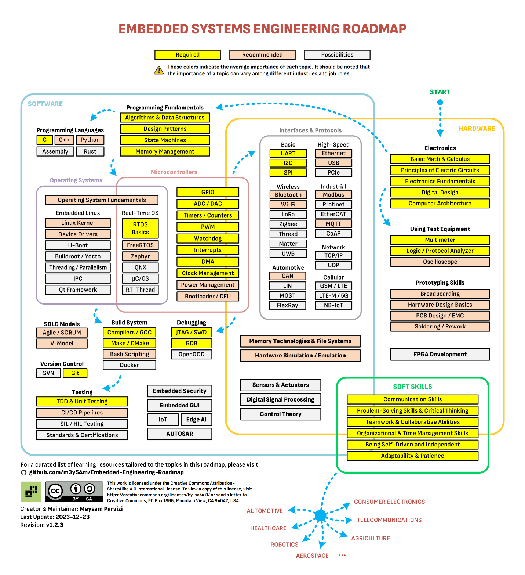

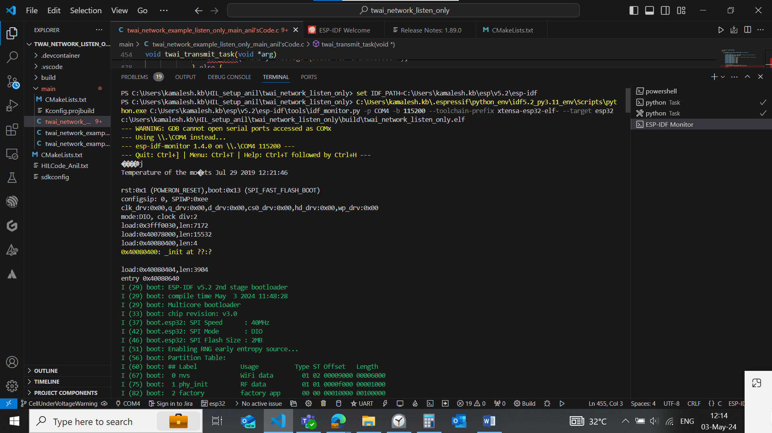

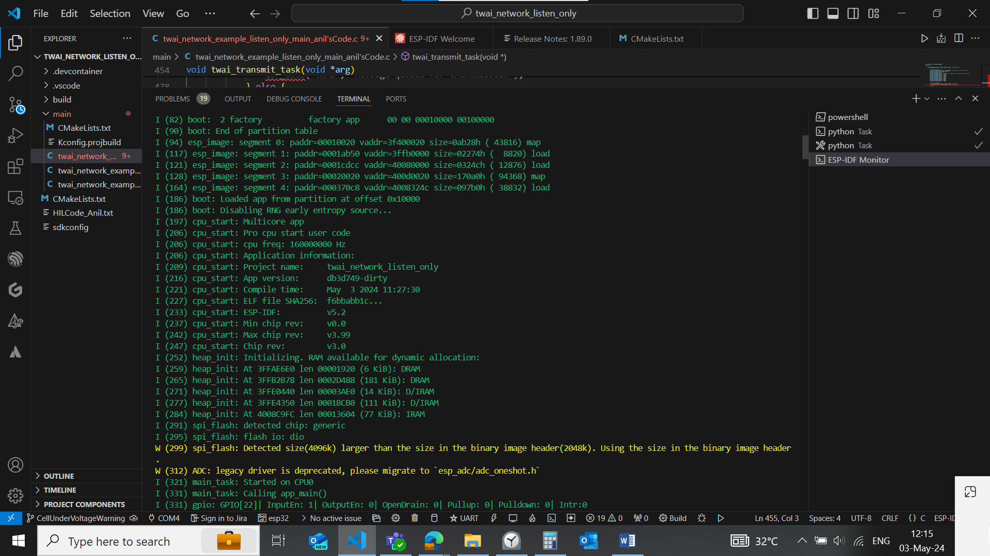

**UART:** [**Lesson 9: UART – Simply Embedded**](http://www.simplyembedded.org/tutorials/msp430-uart/)

**There are five parameters which must be configured correctly to establish a basic serial connection:**

1. **Baud rate**
2. **Number of data bits**
3. **Parity (for parity configured to even, and no of 1s is even then the parity bit is set to 0 and no of 1s is odd then the parity bit is set to 1**
4. **Stop bits**
5. **Endianess (Offer the options to send the data in either LSB and MSB**